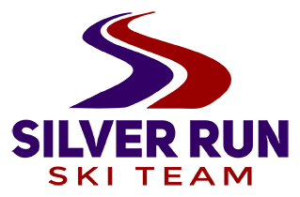
2022 Thanksgiving camp at Big Sky
Silver Run coaches will again offer skiing for our group during the week of Thanksgiving at Big Sky. This is a great opportunity to be on snow early with a training focus! Big Sky will be closed to the public this week. Here are details:
Open to athletes U12 and older. Space is limited to 25 athletes. 6 days on snow!
Thursday Nov. 17 – travel to Big Sky after school. Team van will be available for athlete transportation first come first served (space for 10). We encourage athletes to ride in the van! Dinner meal is included.
Skiing Friday Nov. 18 through Wednesday Nov. 23. Travel home the 23th. Breakfast meal included on departure day.
Lodging will be in the Huntley Lodge, 2 kids per room.
Price includes meals, lift tickets, lodging, and coaching for 6 days and 6 nights.
Big Sky does not allow us to alter the package, so we will not adjust the price for any changes.
Cost is $1825 before Oct. 30, price increases to $1900 after Oct. 30.
Register on active.com with this link: https://campscui.active.com/orgs/SilverRunSkiingFoundation?orglink=camps-registration

