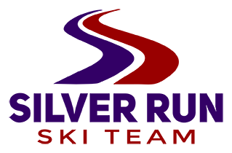 

**Fourth Annual Northern Division Slalom Project**

**Hosted by Silver Run Ski Team**

**WHEN**: December 14-16, 2019 Saturday through Monday.

**WHO**: Northern Division U14 - U21 Athletes

**WHY GO?**

Train with athletes from across the division in a focused and fun environment. Work with experienced Northern Division coaches. Get lots of mileage on great snow. Build a strong foundation for the winter. Have fun!

**WHAT’S INCLUDED?**

3 days on-snow. Entirely Slalom focused camp. Free-skiing, free-skiing drills, gate drills, gate training, video analysis, chalk-talks, evening conditioning and recovery activities. Lane fees and coaching fees. Banquet and bowling night. Camp swag. **The entry fees for the 2 races are included!**

**COACHING STAFF**:

Northern Division coaches to be announced.

Coaches meeting Friday night Dec. 13 at the Silver Strike Lanes back room

**CAMP COST*:$180**

*Travel, lodging, lift tickets, and meals on your own

Athlete and coach tickets are available on the accompanying ticket order form

*Banquet dinner and bowling included December 15

**CAMP WELCOME MEETING**:

All racers please meet in the yurt at 8:15 Saturday morning Dec. 14 .

**TO REGISTER:**

Please follow this link to register: <https://usskiandsnowboard.org/>

Log in, and choose “athlete event registration” Northern Division SL camp and race

Registration opens Nov. 19, 2018

**LODGING:**

The Pollard 406-446-0001 is offering a discount. There are also several VRBO options for team housing.

**FOR MORE INFORMATION PLEASE CONTACT**

Vanessa Selby: [silverrunski@gmail.com](mailto:silverrunski@gmail.com) 406-208-1875